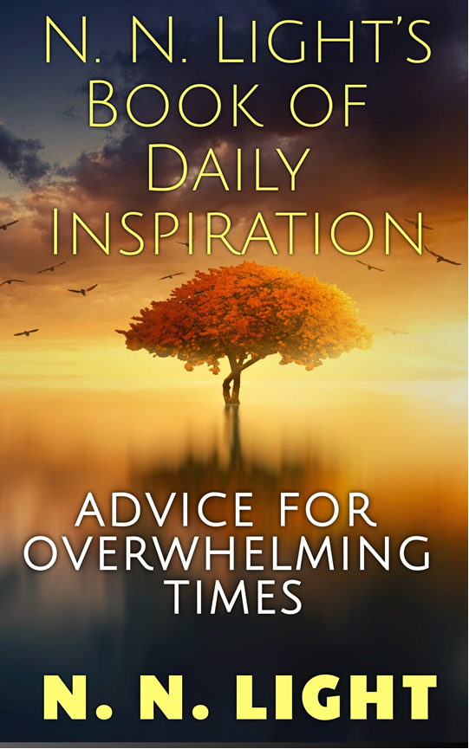
“Spread the Light and inspire others to do the same.” -- N. N. Light
In 2013, we wrote a mission statement and started a blog. We wanted to test a theory. Could one person (or in our case, one couple) use uplifting words to create change?
The answer is a resounding yes! People from all over the world responded to our short inspirational thoughts of the day, and our following grew. What started out as a few people promoting kindness and goodwill turned into a movement. In every city, there are Light-Bearers making a difference and we want you to join us.
Everyone needs inspiration. It doesn’t matter what spiritual belief you hold dear, you have the Light inside you. Kindness, compassion, empathy, encouragement are all attributes of the Light. In this book, you’ll find a ninety second inspirational thought for each day of the year. You’ll be inspiring people to spread the Light daily with our collection of inspirational thoughts. From giving of yourself to simply smiling, these are easy concepts for anyone to apply!

Universal Link | Amazon | BookBub

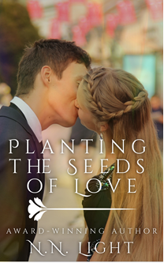
The day her grandfather died, Sally’s life changed forever.
Twenty-Two-year-old Sally Rayton returns to the family farm she deserted four years ago to bury her grandfather. Her plan: to settle her grandfather’s estate and return to her life in the city with her boyfriend, Trevor Mattson.
Her childhood friend, Jack Smith, has other ideas.
Jack convinces Sally to transform the farm into a brewery and fulfill her grandfather’s dream while keeping the Rayton Farm in the family. Sally works side-by-side with Jack while Trevor is hundreds of miles away in the city. The more time she spends with Jack, the stronger her feelings are for him. Sally’s torn between her new feelings for her best friend, Jack and her boyfriend, Trevor.
When Trevor shows up to propose to Sally right before Christmas and finds her in Jack’s embrace, she’s unsure which man she loves. Will it be her best friend and farmer, Jack, or will it be rich, successful Trevor? City or Country… only Sally’s heart knows what’s right and true.

Universal Link | Amazon | BookBub

These are the examples of what your customized graphic might look like (you choose which one you’d like):



